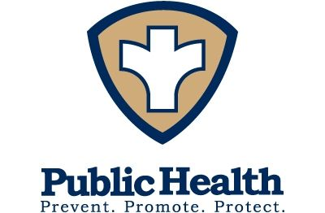

Wayne County Public Health
Board of Health Meeting
Wednesday October 21, 2020

8:30 am ZOOM

- Call the meeting to order
- CARES Funding discussion
- Dedication/Hazard pay
- Update on COVID
- New Discussion
- New meeting
- Adjourn

